4. THE SELECTION GREENHOUSE OF INDUSTRIAL PRODUCTION OF SORTS AND HYBRIDS OF TOMATO, CUCUMBER, SWEET PEPPER AND EGGPLANT BY THE METHOD OF MULTISTOREYED NARROWSHELVING HYDROPONICS AREA 1000 M²

The plan on mark 0.000
Section A-A

The assignment of the object

For the all-the-year-round carrying out of selection process on manufacture of sorts and hybrids of tomato, cucumber, sweet pepper and eggplant.

The basic characteristics

The selection hangar greenhouse T-100А of the all-the-year-round use by the area of 1000 m² is intended for carrying out of selection works on cultivation of plants by the method of multistoreyed narrowshelving hydroponics.
The greenhouse will consist of five sections:
- the seedling section with the area of 62,4 m²;
- the nurseling section with the area of 133,4 m²;
- three vegetable sections of the common area of 728,9 m².
The area of the greenhouse 1000,0 m²
The size of the greenhouse in the plan 14,9 х 72,8 m
The span 14,9 m
Step of bearing racks of the skeleton 2,1 m
The height up to bottom of the water-waste tray 3,5 m
The height up to ridge 6,674 m

Technology

In the greenhouse is applied one of the most progressive technologies - intensive energy-saving, non-polluting cultivation technology of selection sorts and hybrids of the vegetable cultures, by the method of multistoreyed narrowshelving hydroponics.
As the basic selection cultures are accepted: tomatoes, sweet pepper, cucumbers and eggplants.
The orientation of the greenhouse’s ridge is N-S.
Operating mode all-the-year-round.
The method multistoreyed narrowshelving hydroponics allows to increase:
- the effective using of the greenhouses’ volume at placing 25-30 plant on the 1 square meter of the greenhouse area;
- the quantity of the cultivation circles up to 4-5 a year;
- the output of the early production
The total output of production is 1500 kg in one year.
The space between racks is used for cultivation of the green cultures.
The skeleton of the greenhouse

The skeleton of the greenhouse is made from steel zinced structures of factory manufacturing is combined with the engineering-technological equipment. Protection of the greenhouse is made from polycarbonatic panels.
For the natural ventilation of the greenhouse are stipulated ridge and lateral window.
For the maintenance of the best natural airing at over heating, and also, if necessary the greenhouse’s preservation with the completely opening roof is stipulated.
On inclined racks are placed the technological trays (5 storeys) for seedlings, sprouts, herbs and vegetables cultivation.

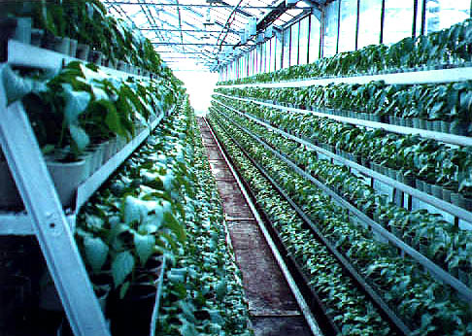

The engineering systems

The hydroponic feeding of plants is carried out with the help of automated solution units.
Heating – the system of planimetric, roofing, floor, underoof heating.
The system of addition lighting – the irradiative installations IRIH15-400-DNaT and IRIH40-150-DNaT.
Electro supply, water supply - from external source. Water removal - in external networks of the water drain.

Heat supply - from own boiler-house or from external source.
The mechanization of productions and automation of maintenance of the microclimate and feeding of plants is stipulated.

Technical and economic parameters

Productivity of object – 1318,3 kg seeds of vegetable cultures in year, including tomatoes – 146,5 kg, cucumbers – 945 kg, peppers – 226,8 kg.
The time of recoupment of the capital investments on construction of the greenhouse is 2,5 years.
The decrease in the charge of water and nutritious solution on the unit of production in 2,0-2,5 times in comparison with the less-volume substrate technology of drop watering.
The reduction of soil quantity in 4-6 times in comparison with less-volume substrate technology of drop watering.
The charge of heat and the electric power on unit of production – 10 Mcal (in 4,5-5,0 times lower, than in greenhouses with the less-volume substrate technology of drop watering).
The high level of automation and mechanization of technological process, reduction of park of the necessary machines and mechanisms on 65-70 % higher then in typical technology on soil.

