С  BC - 2 | BUILDING CATALOGUE | 810-1-42.03-1Н
THE LIMITED SOCIETY  “PATENT” | GREENHOUSE SUCH AS GS- 600А  ALL-YEAR-ROUND UTILIZATION BY THE AREA of 100 m² FOR CULTIVATION Of PLANTS By The METHOD OF MULTISTORIED NARROWSHELVING HYDROPONICS FOR  REGIONS OF THE FAR NORTH | THE RESEARCH AND PROJECT INSTITUTE “GRADOAGROECO-PROM”
 | THE STANDART PROJECT | On 2 pages
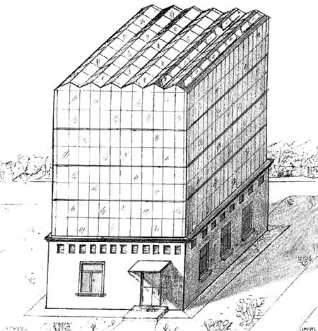
302001, Orel-1, Service board 73, phone/fax (4862) 45-19-48, (4862) 45-17-21, phone (4862) 74-71-10,
e–mail: sharupich@orel.ru, patent@valley.ru; http://www.sharupich.ru, www.valley.ru/~patent

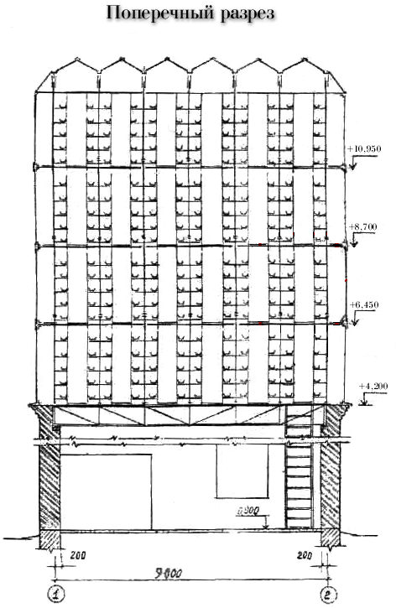

GREENHOUSE SUCH AS GS- 600А  ALL-YEAR-ROUND UTILIZATION BY THE AREA of 100 m² FOR CULTIVATION Of PLANTS By The METHOD OF MULTISTORIED NARROWSHELVING HYDROPONICS FOR  REGIONS OF THE FAR NORTH | THE STANDART PROJECT | Page 2

The description of the design

Greenhous such as the GS - 600А-100 of joint venture the area of 100 m² in Bryansk with an introduction of highly effective non-polluting technology of cultivation of vegetables by a method of multistoried narrowshelving hydroponics.

The basic technological parameters:
- The area of a greenhous in the plan, m² - 100,0
- Annual issue of a commodity output in natural expression, t - 83,5
- In natural expression, kg / m2, - 1070,6
The rough estimate of cost of construction of a greenhouse in contractual prices at the moment of development of the design for 01.01.2003.
In total one thousand rbl. 2038,94
Including. MRW - 576,15
Including the equipment - 1462,79
The cost price of all
Annual issue - 625,82
On ton of vegetables of one thousand rbl. 7,52

The annual charge of the electric power
In total One thousand in kw. h 195,0
On 1 ton of vegetables Kw. h 2,34

Annual heat consumption
In total Gcal 280
On 1 ton of vegetables Gcal 335

Recoupment of investments 48 months.

Produced production is non-polluting, can be applied to a nursery and dietary feed.

Structure of the necessary equipment

- Solution units for multistoried narrowshelving hydroponics such as SUMNH.
- Облучательные installations such as IIGG-15-400-POP-LYfN-ê (Н).
- System CO₂ of a feed.

Building designs and items:
The bases - monolithic.
A face and lateral enclosuring - polycalcareous panels.
A hackberry - metal zinc-coated from a design unweighted a profile.
Coatings, partitions - polycalcareous.
A roof covering - discovering up to 100 %.

Industrial and auxiliary rooms:
Windows - wooden on a series 1.236-6, standard sizes - 2.
Floors - with a coating from concrete
Doors - internal wooden on a series 1.136-10, standard sizes - 5.
Doors - outside - from aluminium alloys in accordance with GOST 24584-81 and wooden on a series 1.136.5.19, standard sizes - 5.

