С  BC - 2 | BUILDING CATALOGUE | 810-1-42.03-1Н
THE LIMITED SOCIETY  “PATENT” | lightproof GREENhouse with  Square of 5000 m² for AREAS of  FAR NORTH | THE RESEARCH AND PROJECT INSTITUTE “GRADOAGROECOPROM”
 | THE STANDART PROJECT | On 2 pages
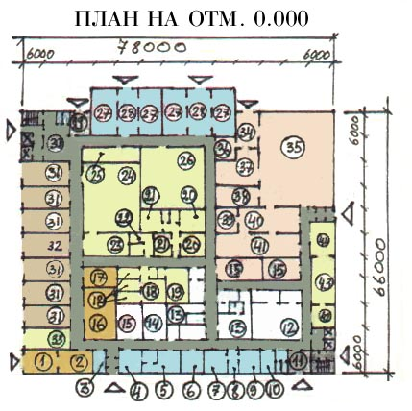
302001, Orel-1, Service board 73, phone/fax (4862) 45-19-48, (4862) 45-17-21, phone (4862) 74-71-10,
e–mail: sharupich@orel.ru, patent@valley.ru; http://www.sharupich.ru, www.valley.ru/~patent

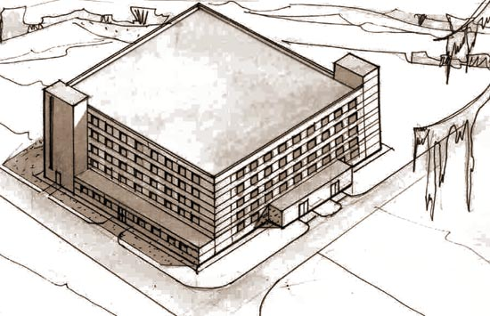
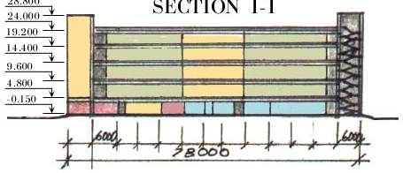
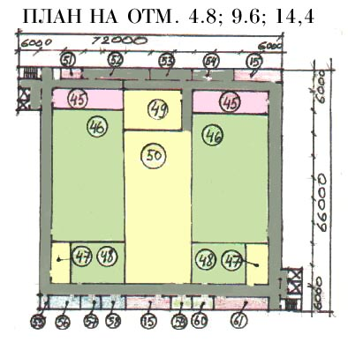
lightproof GREENhouse with  Square of 5000 m² for AREAS of  FAR NORTH | THE STANDART PROJECT | Page 2

THE CONSTRUCTIVE DECISION

The constructive scheme of a building - framed. Supporters of a hackberry are metal columns and beam heads, external walls - trizonal panels; partitions in chambers - dungeons - brick. Bridgings - modular hollow slabs.

The characteristics of object.

Given cultivation structure is intended for year-round manufacture of vegetables at utilization of an artificial irradiating.
In structure of a hothouse are stipulated industrial, household and auxiliary zones.
In structure of an auxiliary zone are stipulated:
- Vegetable branch of a square of 1495,77 m² (2 floor)
- Vegetable branch of a square of 1510,17 m² (3 floor)
- Vegetable branch of a square of 1510,17 m² (4 floor)
- Vegetable branch of a square of 1505,02 m² (5 floor)

The industrial zone is placed in five levels on a mark 0,000; 4.800; 9600; 14.40019.200
The floor space of rooms for cultivation сеянцев, seedling, vegetables and wild strawberry compounds 7987,24 m². The auxiliary area растворных units, power units, rooms of preparation and a storage of peat, rooms of sprouting of seeds and replantings of seedlings, etc. compounds 6107,24 m².
In structure of an industrial zone of 0,000 m are stipulated on a mark
- A room of preparation of peat - 430,22 m²
- A room of a storage of peat - 86,7 m²
- A room of ready soil - 70,9 m²
- A technical room - 35,79 m²
- A room of filling of cartridges peat - 86,8 m²
- A room of washing and disinfection of cartridges - 112,78 m²
- A room of mother liquors - 228,56 m²

THE ESTIMATE OF COST - 102537,55 thousand rbl. (in the prices of 2003).

