С  BC - 2 | BUILDING CATALOGUE | 810-1-42.03-1Н
THE LIMITED SOCIETY  “PATENT” | Lightproof GREENhouse  4 floor with the area of cultivation of 5000 m² for REGIONS OF THE FAR NORTH | THE RESEARCH AND PROJECT INSTITUTE “GRADOAGROECO-PROM”
 | THE STANDART PROJECT | On 2 pages
302001, Orel-1, Service board 73, phone/fax (4862) 45-19-48, (4862) 45-17-21, phone (4862) 74-71-10,
e–mail: sharupich@orel.ru, patent@valley.ru; http://www.sharupich.ru, www.valley.ru/~patent

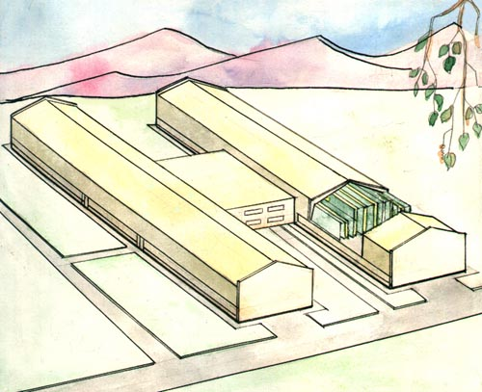
The characteristics of object

Cultivation of seedling of vegetable cultures and adult plants is accepted on a method of multistoried narrowshelving culture in multistoried narrowshelving scantlings installed on slope supports (trapezes) at a ladder-shaped arrangement of storeys on a vertical.
The dimensions of trapezes (height, width on a bottom) 2000X 1200 mm.
Arrangement of trays on trapezes for рассадных and vegetable chambers on 5 storeys. Distance between trays 400 mm, up to a floor 450 mm.
In seedlings chambers the dimensions of trays the following: width in a bottom 220 mm, on top part 250 mm, depth 80 mm.
In vegetable chambers the dimensions of trays - width in a bottom 100 mm, on top part 130 mm, depth 80 mm.
In branch сеянцев scantlings without covers, vegetable and seedling scantlings with covers.
Cultivation of seedling and vegetables is provided in small pots (plastic), the dimensions in a bottom 85 mm, on top part 120 mm, depth 100 mm, filled in by peat.
Output of seedling from one running metre of a tray-16 piece.
Watering and supplementary feeding of plants is carried out as follows: сеянцы a method of a underflooding, seedling and vegetables a duct, a level of the solution proceeding on trays 2-3 mm. A mode of watering: 20 minutes - watering, 20 minutes - a rest.

Lightproof GREENhouse  4 floor with the area of cultivation of 5000 m² for REGIONS OF THE FAR NORTH | THE STANDART PROJECT | Page 2

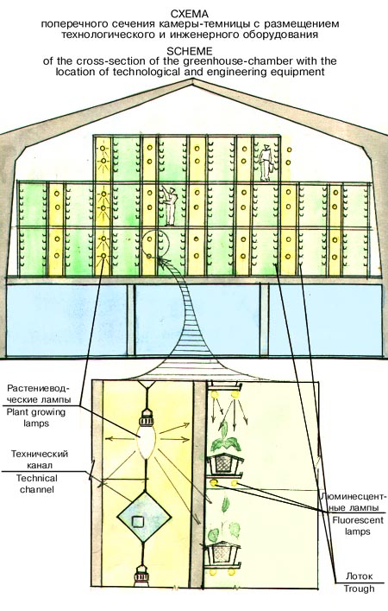

Atmospheric humidity in chambers for cultivation of seedling and vegetables of a tomato on production of 60-70 %, сеянцев seedling and vegetables of a cucumber - 80-90 %.
For processing plants by solutions of toxic materials, with the purpose of externination of pests and diseases, back-pack sprayers ОРР-IА of "Ayr" are provided
In chambers for cultivation of seedling it is provided lighting plants with the help special irradiation the device consisting of aerated boxes in which lamps of Dm - 4-3000 and flat light wave guide cables and a reflective and light-diffusing film are inbuilt.

