С  BC - 2 |  | BUILDING CATALOGUE |  | 810-1-42.03-4Н
THE LIMITED SOCIETY  “PATENT” |  | Super-GREENhouse of the third generation with a lightproof covering such as "Sandwich" of the GS- M-1000А-1000-SNP Square of 1500 m² for construction in  Regions of the Far North |  | THE RESEARCH AND PROJECT INSTITUTE “GRADOAGROECO-PROM”
 |  | THE STANDART PROJECT |  | On 2 pages
302001, Orel-1, Service board 73, phone/fax (4862) 45-19-48, (4862) 45-17-21, phone (4862) 74-71-10,
e–mail: sharupich@orel.ru, patent@valley.ru; http://www.sharupich.ru, www.valley.ru/~patent

 | THE PLAN ON 0.000 |  | THE PLAN ON +3.300
 | 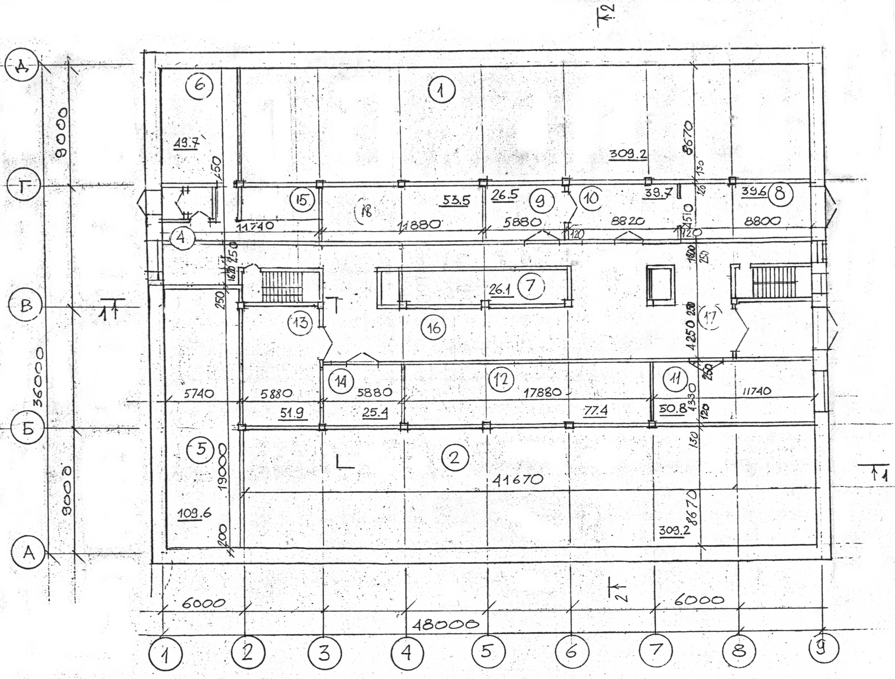 |  | 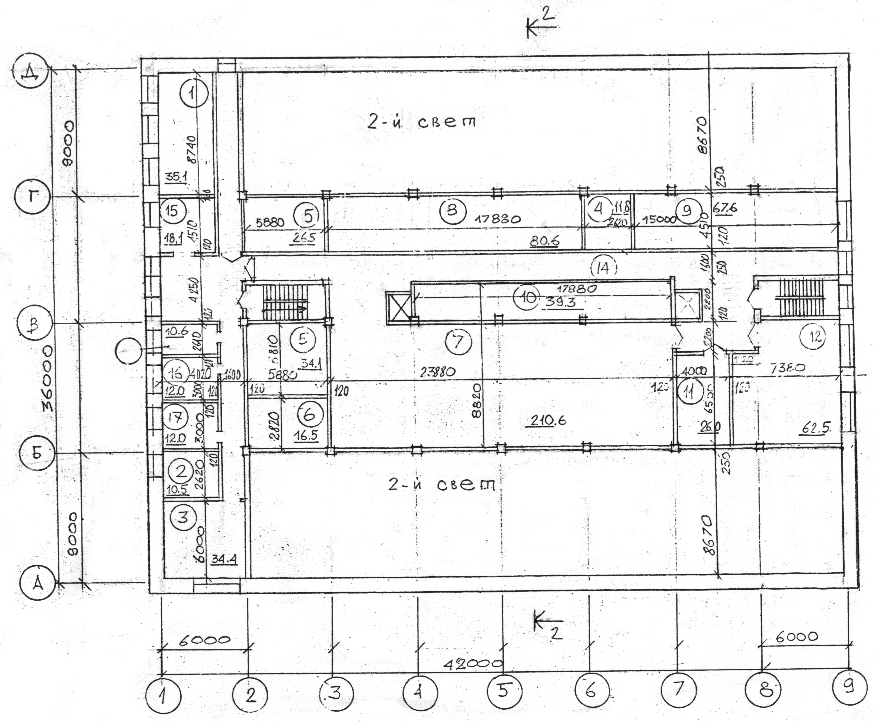
 | SECTION 1-1 |  | SECTION A-D
 | 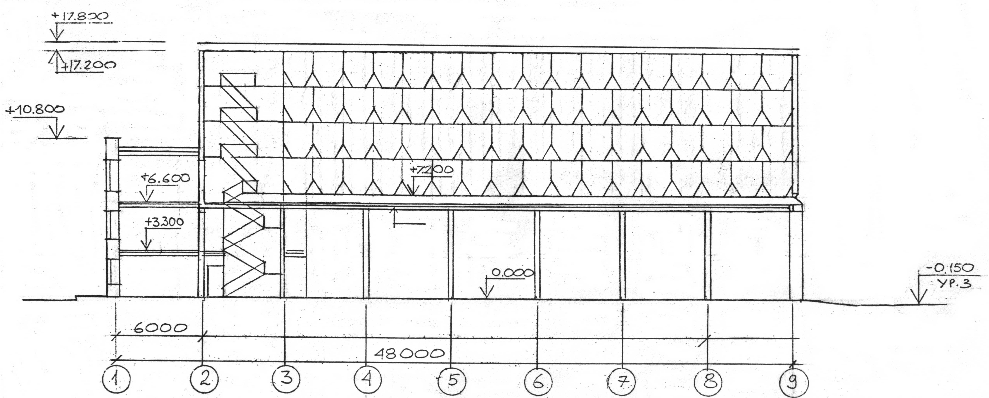 |  | 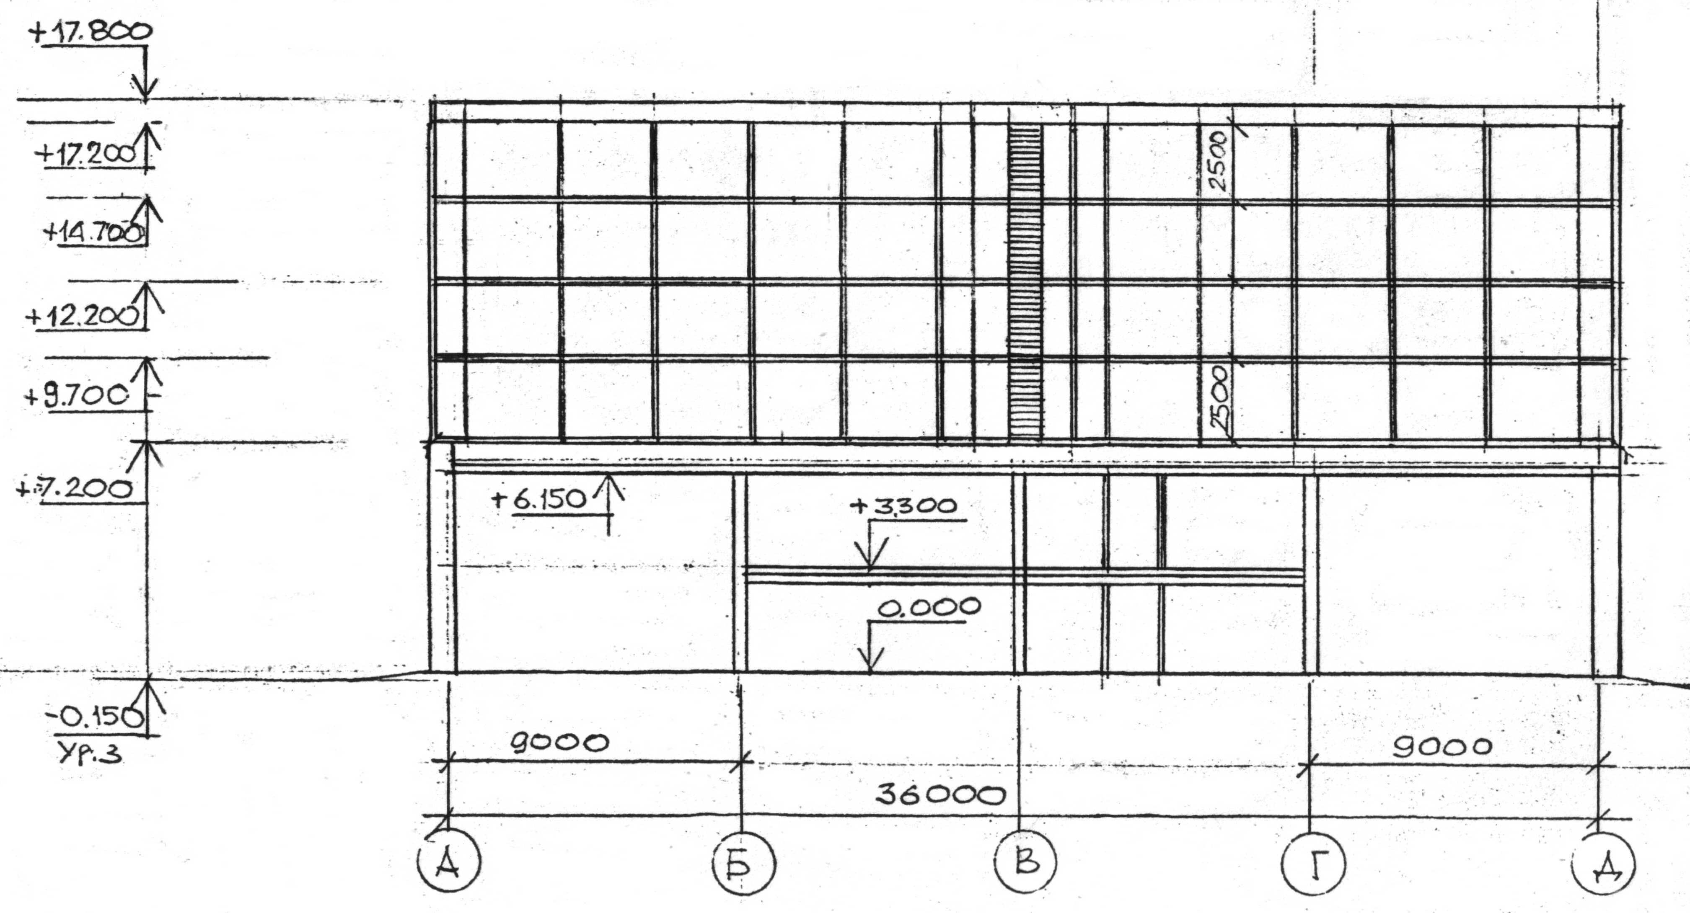

Temperature of the most cold five-day week a minus 40⁰С.
Temperature of the most cold day a minus 48⁰С.
Average relative humidity of air for January of 79 %, motility of air no more than 0,8 m/sec

Super-GREENhouse of the third generation with a lightproof covering such as "Sandwich" of the GS- M-1000А-1000-SNP Square of 1500 m² for construction in Regions of the Far North | THE STANDART PROJECT | Page 2

THE BASIC CHARACTERISTICS

Span - 12 m;
A walk of columns - 6 m;
The area of a greenhouse - 1500 m²;
Efficiency - 160 kg / m².

THE CONSTRUCTIVE DECISION

The constructive scheme of a building - framed. Supporters of a hackberry are metal columns and beam heads span of 12 m, with a walk of 6 m. External walls - trizonal panels; partitions in chambers - dungeons - brick. Bridgings - modular hollow slabs.

The characteristics of object.

The building of a greenhouse of the third generation has five branches: three vegetable, one seedling and one branch of seeds.
Each branch is placed in one volume on 4 floors. Interfloor coverings are absent. For technological service metal trellised pathes, permeable for air are stipulated.
On each floor trays with plants for which the artificial light status is provided are placed. On conditions of technology in each branch simultaneously in a diurnal mode two floors, and two floors in a night mode can work. In a diurnal mode lamps of lighting work, in night they are switched - off. Then the modes of operations on floors vary.
On perimeter of a greenhouse double enclosurings which are used for a fence of a return air are provided.
Above bridging Ii-go of a floor the interfloor not through passage space for uniform distribution of conditioned air is provided.
Roof covering of a greenhouse flat, warmed.
On each floor for technological service on the centre of a greenhouse technological pathes are stipulated, therefore branches on all floors divided into two halves. The central path is closed partition, for an orifice in branches stipulates doors.

The "know-how".

The lightproof multistory greenhouse is intended for cultivation of seedling and vegetable cultures.
Annual production rate of a multistory greenhouse compounds 835 t The mode of operation of a lightproof greenhouse - year-round.

THE ESTIMATE OF COST - 35480,73 thousand rbl. (in the prices of 2003).

