С  BC - 2 | BUILDING CATALOGUE | 810-1-42.03
THE LIMITED SOCIETY  “PATENT” | THE GREENHOUSES’ BLOCK T-100A OF THE ALL-THE-YEAR-ROUND USE WITH THE AREA 6 HA FOR PLANTS’ CULTIVATION BY THE METHOD OF MULTISTOREYED NARROWSHELVING HYDROPONICS | THE RESEARCH AND PROJECT INSTITUTE “GRADOAGROECOPROM”
 | THE STANDART PROJECT | On 2 pages
302001, Orel-1, Service board 73, phone/fax (4862) 45-19-48, (4862) 45-17-21, phone (4862) 74-71-10,
e–mail: sharupich@orel.ru, patent@valley.ru; http://www.sharupich.ru, www.valley.ru/~patent

FACADE

PLAN

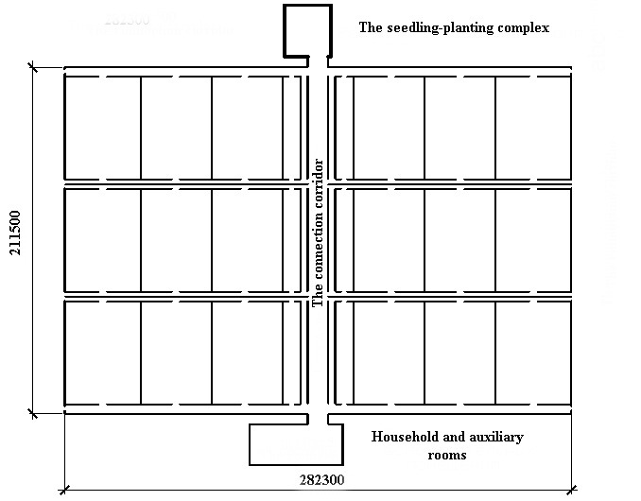

Range of application: areas with an ordinary geological environment, settlement t an outside air-40о C

The description of the PROJECT

In a greenhouse the progressive technology - intense energysaving non-polluting technology of cultivation of seedling, vegetables, berries, flowers, greens by a method of multistoreyed narrowshelving hydroponics (MNH) is applied.
In every greenhouse the branch of seddling, three vegetable branches is stipulated.
In the block of greenhouses as the basic cultures tomatoes, a sweet pepper and cucumbers are accepted.
18 various cultures, and also a unlimited panel of greens cultures can simultaneously be cultivated.
THE GREENHOUSES’ BLOCK T-100A OF THE ALL-THE-YEAR-ROUND USE WITH THE AREA 6 HA FOR PLANTS’ CULTIVATION BY THE METHOD OF MULTISTOREYED NARROWSHELVING HYDROPONICS | THE STANDART  PROJECT | Page 2
The orientation of technological trays N-S.
The growing of the vegetables is suited in plastic holders and suits which stated in technological trays.
The exit of production all-year-round/
The method of MNH allows to increase:
- the field of culturevents in 4-5 in a year;
- Seed spacing of plants up to 25-30 piece/m²;
- The output of early production at natural illumination in 2-3 times is more, than on a soil;
- General output of production up to 120 kg / m² annually;
- Output of seedling about 1 m² up to 100 piece.
The basic characteristics:
- The area of the block of greenhouses - 6,0 hа
- The area of a greenhouse - 1,0 га
- Span - 2,1 m
- Walk of racks - 1,5 m

Engineering systems

Hydroponics plant nutrition is carried out with the help of automized solution units.
Systems of multiplanimetric heating are accepted.
It is stipulated: planimetric (lateral, face), roofing, floor-stand and heating.
Systems of lighting - irradiation installations.
Systems of an additional artificial irradiating are stipulated, variants of cultivation of adult plants without an additional artificial irradiating and with an additional artificial irradiating vigor of the area of greenhouses of 300 and 500 Wt/m² are stipulated.
Heat supply - from own boiler room or an external source.
Mechanization of productions and automation of maintenance of a controlled environment and plant nutrition is stipulated.
Electric power supply, water supply - from an external source. Water removal - in external nets of the sanitary piping.
Mechanization of productions and automation of maintenance of a controlled environment and plant nutrition is stipulated.

Building designs and items

A multispan greenhouse.
The bases - reinforced-concrete, плитного type.
A face and lateral enclosuring - polycalcareous panels.
A hackberry - metal zinc-coated from the bent profiles.
Coatings, partitions - polycalcareous panels.
A roof covering - opens up to 100 %.
A Seedling-landing complex:
- Walls - brick;
- Slab roofs - modular ridge on a series 1.465.1-21.94.1;
- Beams of a covering - modular on a series 1.465.1-10/93 issue 1;
- The bases - modular tape.
Windows - wooden on a series 1.236-6, standard sizes - 2.
Floors - with a covering from concrete
Doors - internal wooden on a series 1.136-10, standard sizes - 5.
Doors - outside - from aluminium alloys in accordance with GOST 24584-81 and wooden on a series 1.136.5.19, standard sizes - 5.
A gate - opens from tubular a profile.

The estimate of cost - 200492,47 thous. roub. (in the prices of 2003)
Labour costs - 197227,1 human./day.

