1. THE SEEDLING BLOCK GREENHOUSE T-100A WITH MULTISTOREYED NARROWSHELVING HYDROPONICS (AREA=1000 M²) FOR GREENHOUSE COMBINES WITH THE AREA OF 6 HA WITH SOIL TECHNOLOGY OF VEGETABLE PRODUCTION CULTIVATION

The plan on mark 0.000

Section A-A

The assignment of the object

The manufacture of seedlings and sprouts of vegetable cultures for the closed and open soil.

The basic characteristics

The block greenhouse T-100А is intended for the all-the-year-round use by the area of 1000 m² for cultivation of seedlings and sprouts by the method of multistoreyed narrowshelving hydroponics as a part of greenhouse combine with the area of 6 ha.
The greenhouse is consist of the seedling section with the area of 198,5 m², the nurseling section with the area of 760,7 m2, the solution unit and the panel board.
The area of the greenhouse 1000,0 m²
Span 2,1 m
The step of bearing racks of the skeleton 1,5 m
The height up to bottom of water-waste tray 3,45 m
Height up to ridge 3,986 m

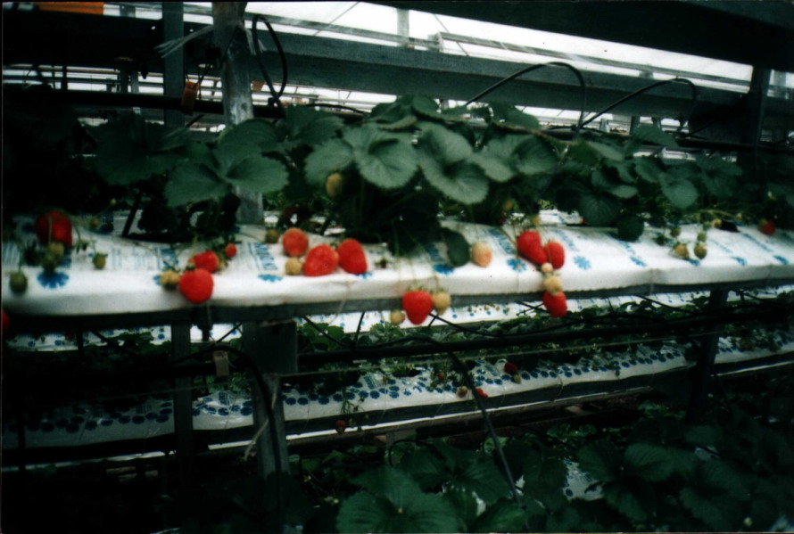

Technology

In the greenhouse is applied one of the most progressive technologies - intensive energy-saving, non-polluting technology of seedlings, sprouts of vegetable cultures, herbs and green cultures cultivation by the method of multistoreyed narrowshelving hydroponics.
The orientation of the greenhouse’s ridge is N-S.
The operating mode - all-the-year-round.
The method of multistoreyed narrowshelving hydroponics allows to increase:
- the effective using of the greenhouses’ volume;
- the quantity of the cultivation circles at cultivation of sprouts;
The total output of production is 12500,1 т in one year.
The space between racks is used for cultivation of the green cultures.
The skeleton of the greenhouse

The skeleton of the greenhouse is made from steel zinced structures of factory manufacturing is combined with the engineering-technological equipment. Protection of the greenhouse is made from polycarbonatic panels.
The roof of the greenhouse is completely open. The area of opening varies from 0 up to 100 % from the surface of the roof.
On inclined racks are placed the technological trays (5 storeys) for seedlings, sprouts, herbs and green cultures cultivation.

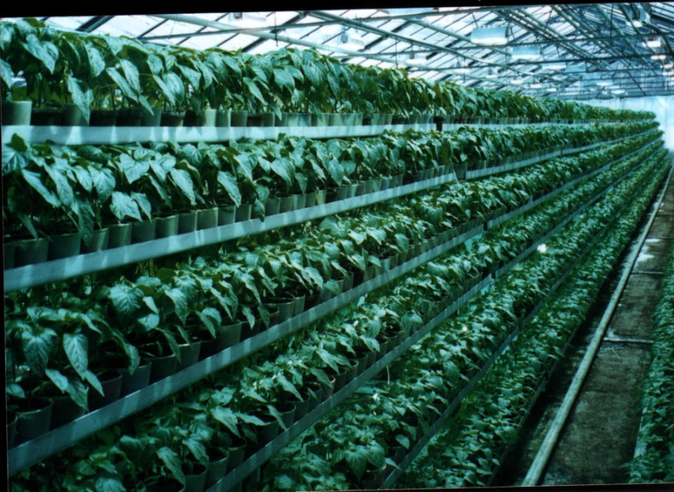

The engineering systems

The hydroponic feeding of plants is carried out with the help of automated solution units.
Heating – the system of planimetric, roofing, floor, underoof heating.
The system of addition lighting – the irradiative installations IRIH15-400-DNaT and IRIH40-150-DNaT.
Electro supply, water supply - from external source. Water removal - in external networks of the water drain.
Heat supply - from external source.
The mechanization of productions and automation of maintenance of the microclimate and feeding of plants is stipulated.

Technical and economic parameters

The productivity of object: seedlings - 229414 pieces in one year, sprouts - 225810 pieces in one year, green cultures - 2,3 t.
Due to high-quality sprouts, the productivity of vegetables increases. The output of tomato from vegetable sections 466,2 t. The output of cucumber - 12010,7 t.
The time of recoupment of the capital investments on construction of the greenhouse is 2,5 years.
The decrease in the charge of water and nutritious solution on the unit of production in 2,0-2,5 times in comparison with the less-volume substrate technology of drop watering.
The reduction of soil quantity in 4-6 times in comparison with less-volume substrate technology of drop watering.
The charge of heat and the electric power on unit of production – 10 Mcal (in 4,5-5,0 times lower, than in greenhouses with the less-volume substrate technology of drop watering).
The maintenance of the output of sprouts about 1 m² up to 100 piece.
The high level of automation and mechanization of technological process, reduction of park of the necessary machines and mechanisms on 65-70 % higher then in typical technology on soil.

