С  BC - 2 | BUILDING CATALOGUE | 810-1-42.03-2Н
THE LIMITED SOCIETY  “PATENT” | Lightproof GREENhouse  With the area of cultivation of 1000 m² for INTENSE NON-POLLUTING CULTIVATION of VEGETABLES by the METHOD OF multistoried narrowshelving hydroponics FOR AREAS  FAR NORTH | THE RESEARCH AND PROJECT INSTITUTE “GRADOAGROECO-PROM”
 | THE STANDART PROJECT | On 2 pages
302001, Orel-1, Service board 73, phone/fax (4862) 45-19-48, (4862) 45-17-21, phone (4862) 74-71-10,
e–mail: sharupich@orel.ru, patent@valley.ru; http://www.sharupich.ru, www.valley.ru/~patent

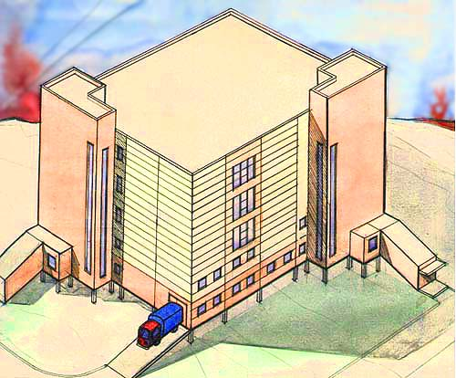
THE CONSTRUCTIVE DECISION

The constructive scheme of a building - framed. Supporters of a hackberry are metal columns and beam heads span of 12 m, with a walk of 6 m. External walls - trizonal panels; partitions in chambers - dungeons - brick. Bridgings - modular hollow slabs.

The characteristics of object.

Given cultivation structure is intended for year-round manufacture of vegetables - a cucumber, a tomato and greens cultures (an onions on a feather) - in a mode of a photoculture.
In a lightproof greenhouse the intense non-polluting nonwaste technology of cultivation of plants by a method of multistoried narrowshelving hydroponics is applied energysaving complete with highly effective plumbing system and energysaving lightproof cultivation structures of complete delivery "on a turn-key basis".

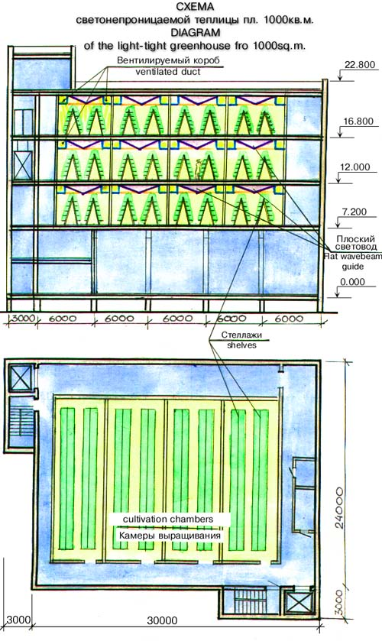  Lightproof GREENhouse  With the area of cultivation of 1000 m² for INTENSE NON-POLLUTING CULTIVATION of VEGETABLES by the METHOD OF multistoried narrowshelving hydroponics FOR AREAS  FAR NORTH | THE STANDART PROJECT | Page 2

The greenhouse will consist of branches of seedlings and vegetable.
Cultivation of plants is effected on the narrow trays posed in five storeys on height on slope supports, forming a scantling of the trapezoid form.
Height of scantlings - 2.1 m, width in the inferior zone - 1.2 m.
Scantlings are placed in the chambers equipped with necessary engineering systems, bolstering an optimum mode for growth and a fruit brearing of plants (light, warmly, humidity, etc.).
Row spacings of scantlings - 0.9 m; they are used for service of plants and pass of people.
Chambers three floors of a building, height of floors - occupy 4.8 m. Amount of chambers - 12, on 4 chambers on a floor.
Rooms of servicing purpose are placed on a ground floor and on the subsequent - on perimeter of a building.
For moving people and loads corridors, ladders, lifts, an approach ramp are stipulated.
In chambers of cultivation of plants it is provided lighting of plants with the help special irradiation device consisting of aerated boxes in which lamps of Dm - 4-3000 are inbuilt, and flat light wave guide cables from a reflective and light-diffusing film.

