3. THE GREENHOUSE FOR SEEDLINGS, SPROUTS AND VEGETABLES CULTIVATION BY THE METHOD OF MULTISTOREYED NARROWSHELVING HYDROPONICS WITH THE AREA OF 1000 М²

The plan on mark 0.000
Section A-A

The assignment of the object

The manufacture of seedlings and sprouts of vegetable cultures, herbs, green cultures, strawberry, flowers and mushrooms.

The basic characteristics

The block greenhouse T-100А is intended for the all-the-year-round use by the area of 1000 m² for cultivation of seedlings and sprouts by the method of multistoreyed narrowshelving hydroponics.
The greenhouse will consist of five sections:
- the seedling section with the area of 56,4 m²;
- the nurseling section with the area of 111,6 m2;
- three vegetable sections of the common area of 761,4 m².
The area of the greenhouse 1000,0 m²
The size of the greenhouse in the plan 14,0х71,28 m
The span 2,3 m
Step of bearing racks of the skeleton 1,5 m
The height up to bottom of the water-waste tray 3,3 m
The height up to ridge 3,901 m

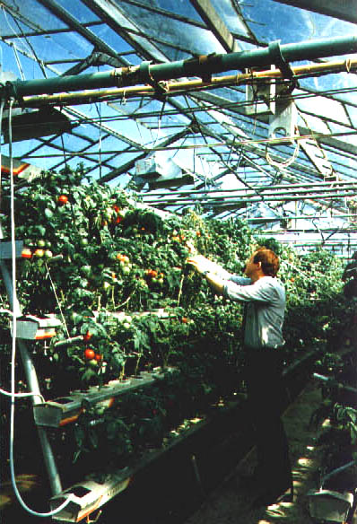

Technology

In the greenhouse is applied one of the most progressive technologies - intensive energy-saving, non-polluting technology of seedlings, sprouts of vegetable cultures, herbs and green cultures cultivation by the method of multistoreyed narrowshelving hydroponics.
The orientation of the greenhouse’s ridge is N-S.
The operating mode - all-the-year-round.
The method of multistoreyed narrowshelving hydroponics allows to increase:
- the effective using of the greenhouses’ volume at placing 25-30 plant on the 1 square meter of the greenhouse area;
- the quantity of the cultivation circles up to 4-5 a year;
- the output of the early production
The total output of production is 120 kg/m² т in one year.
The space between racks is used for cultivation of the green cultures.

The skeleton of the greenhouse

The skeleton of the greenhouse is made from steel zinced structures of factory manufacturing is combined with the engineering-technological equipment. Protection of the greenhouse is made from polycarbonatic panels.
The roof of the greenhouse is completely open. The area of opening varies from 0 up to 100 % from the surface of the roof.
On inclined racks are placed the technological trays (5 storeys) for seedlings, sprouts, herbs and green cultures cultivation.

The engineering systems

The hydroponic feeding of plants is carried out with the help of automated solution units.
Heating – the system of planimetric, roofing, floor, underoof heating.
The system of addition lighting – the irradiative installations IRIH15-400-DNaT and IRIH40-150-DNaT.
Electro supply, water supply - from external source. Water removal - in external networks of the water drain.
Heat supply - from external source.
The mechanization of productions and automation of maintenance of the microclimate and feeding of plants is stipulated.

Technical and economic parameters

Productivity of object - 89,4 t of vegetables in year, including tomatoes - 54,8 t, cucumbers - 27,2 t, green cultures - 7,4 t.
The time of recoupment of the capital investments on construction of the greenhouse is 2,5 years.
The decrease in the charge of water and nutritious solution on the unit of production in 2,0-2,5 times in comparison with the less-volume substrate technology of drop watering.
The reduction of soil quantity in 4-6 times in comparison with less-volume substrate technology of drop watering.
The charge of heat and the electric power on unit of production – 10 Mcal (in 4,5-5,0 times lower, than in greenhouses with the less-volume substrate technology of drop watering).
The decrease in quantity of nitrates in production up to 30-40 mg/kg (8-10 time less, in comparison with normative)
The maintenance of the output of sprouts about 1 m² up to 100 piece.
The high level of automation and mechanization of technological process, reduction of park of the necessary machines and mechanisms on 65-70 % higher then in typical technology on soil.

